“Serving those who serve.”

2017
Annual Report
Miami Valley Fire / EMS Alliance
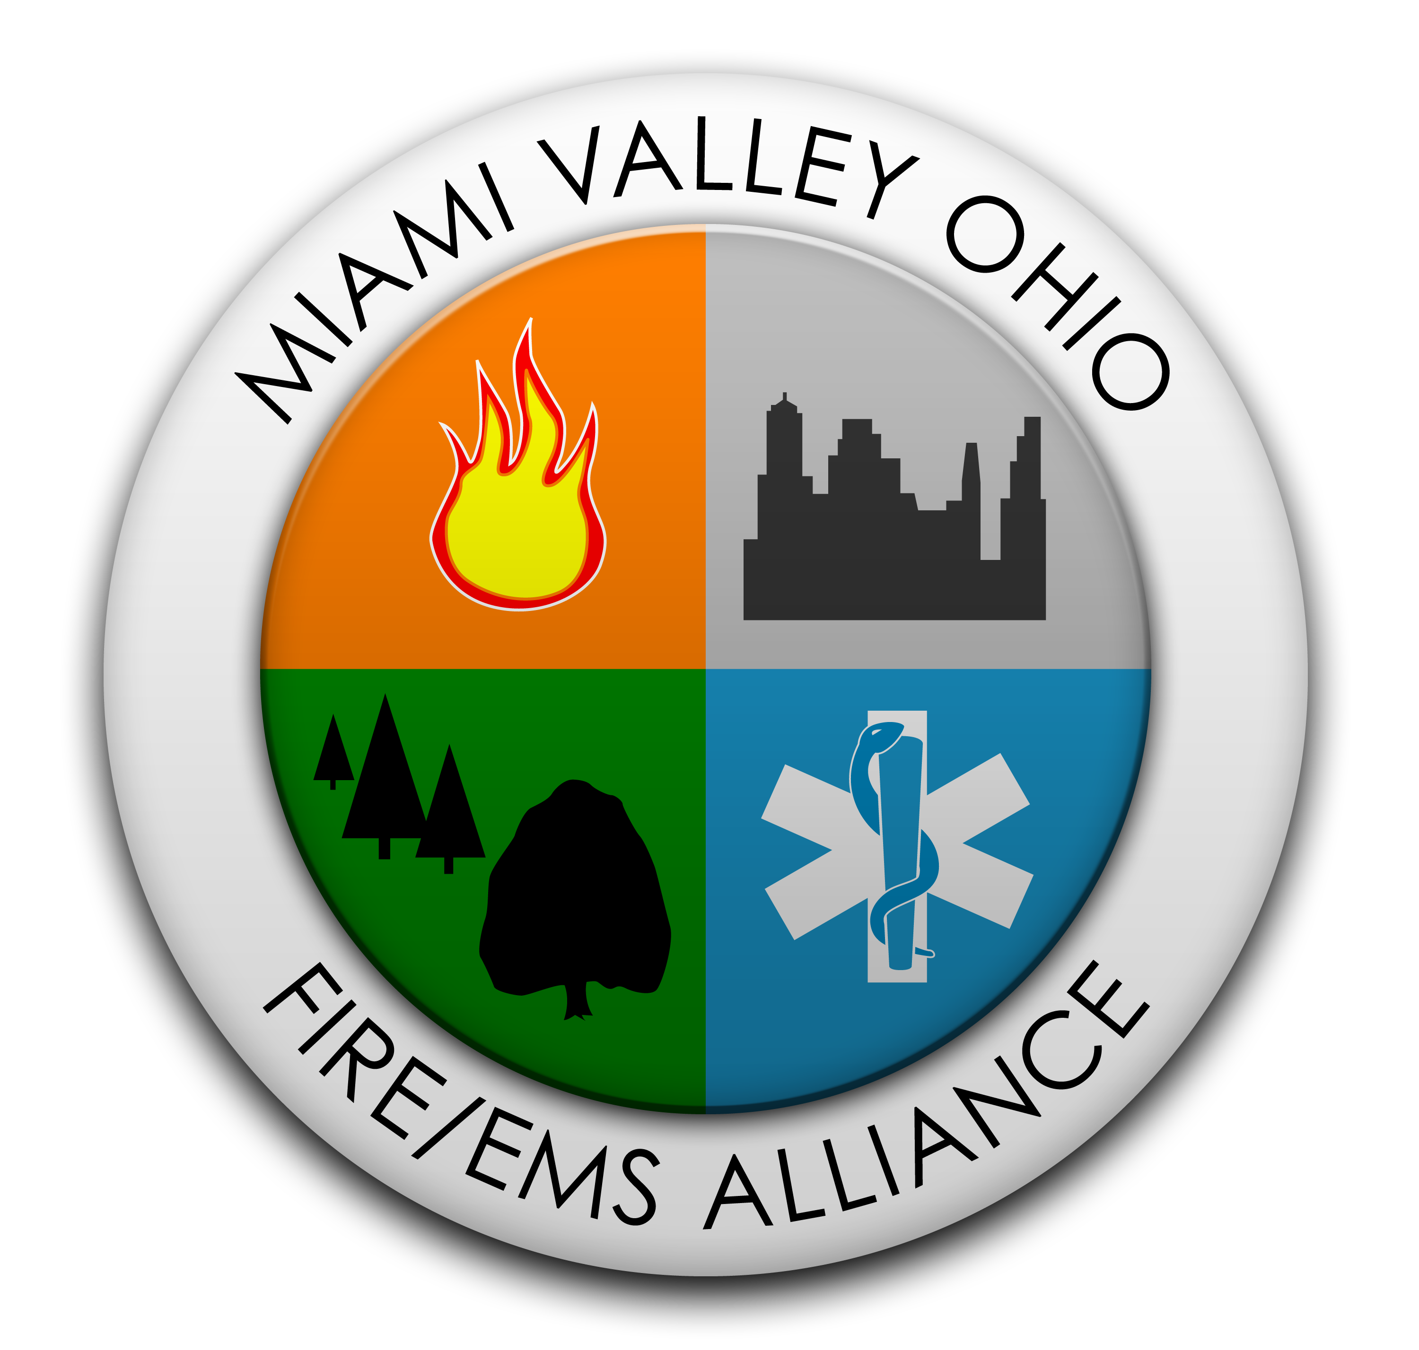

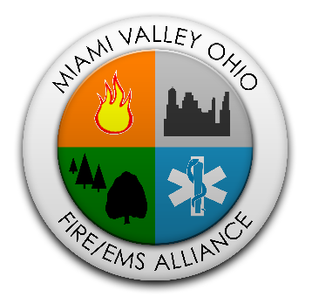

Dear Chair Garver:
I am pleased to present the 2017 Miami Valley Fire/EMS Annual Report. This is the first of the Annual Reports I have the honor to present as the new Executive Director. For someone who has been involved in several capacities, since the inception of this organization, I can honestly say for the past 24 years the Alliance has provided the Miami Valley with an essential tool to address problems and issues and concerns facing the fire and Emergency Medical Services of our communities. The scope and complexities of the challenges facing the delivery of our service to the citizens of the region are often beyond the abilities and resources of local government. The Alliance has proven time and time again through cooperation, collaboration, and mutual support, we can improve the quality of services we provide our customers.
The 2017 Annual Report highlights many of the accomplishments of the past year. I want to thank the Board of Directors, the Executive Committee, the various members of our working committees, the Alliance staff, the CPAT Protectors, the Assessment Center Assessors, the Dayton Regional Hazardous Materials Team (Hazmat) and Region Three Strike Team (R3RST) Advisory Boards, and the Hazmat and R3SRT Coordinators for all the long hours and hard work. It is their dedication and selfless service to the improvement and advancement of the fire service that truly is the Alliance Advantage.

Sincerely,
Franklin E. Clay
Executive Director
Miami Valley Fire/EMS Alliance

Executive Summary
2017: A year of transition for the Miami Valley Fire / EMS Alliance.

- Jacqueline Leland, Executive Director, retired in April 2017. Jackie had been employed at the Miami Valley Fire / EMS Alliance (Alliance) since August 2, 2002.

- Franklin E. Clay was hired on February 1, 2017 as the new Executive Director. This is a part-time position; working no less than 24 hours per week. This part-time position does not allow for accrual of vacation or sick leave and is not covered under the Alliance health insurance program. Frank continues to work with members and non-members on Assessment Centers and ISO support.

- Valerie Tate, was promoted to Office Manager. This is a full-time position. Valerie and Frank have been working together on a consistent basis to implement the transition in a smooth and efficient way.

- Robert Hogeland, CPAT administrator, continues to do a remarkable job coordinating CPAT exams, schedules, and trainings for new proctors.

- CPAT Proctors are well-trained guides for candidates seeking employment; not only with Alliance member fire departments, but many departments throughout Ohio, Michigan, Kentucky, Pennsylvania, and as far away as Connecticut.

- Assessment Center Proctors/Assessors are volunteers who do an exceptional job of working at the various dimensions of promotional testing within the fire departments.

2017: A strong financial year.
The Alliance financial position is strong. The FY 2015-16 Annual A-133 Single Audit results were excellent. This is due to the thoroughness of the staff who carefully and accurately managed public funds. At the end of the fiscal year FY 2016-2017, the Alliance financials were in a positive position. Comparing calendar year 2016 to 2017:
- Entry Level Testing Income dropped from $2,006.60 to $1,472.00.
- Assessment Centers increased from $2,485.00 to 2,750.00
- CPAT Income increased in 2017 to a high of $25,090.00 from $24,365.00. The Alliance proctors’ exams for the City of Dayton, per our agreement, in lieu of paying for Dayton candidates, the Alliance proctors the exam to acquire the CPAT equipment. At this printing, the Alliance has 103 more CPAT exams to go to complete the agreement. In 2017, the total CPAT expenses were $1,537.80 for equipment repairs and maintenance, the purchase of water and Gatorade, and office supplies.

2017: A year of increased firefighter hiring.
National Testing Network entry level testing is not only for firefighters, but also law enforcement, call taker/dispatchers, and promotions. Tests were scheduled on a regular basis to provide opportunities for members. While not all Alliance members use CPAT and the National Testing Network (Ergometrics) for their hiring process, all members received numerous spreadsheets with contact information, certifications, and scores. Vacancies for firefighter positions have stayed high throughout the region in 2017.

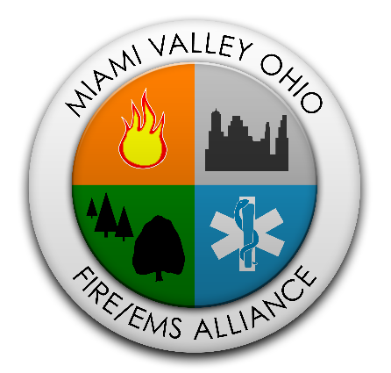
MIAMI VALLEY FIRE/EMS ALLIANCE.

The Miami Valley Fire / EMS Alliance, a Regional Council of Government, was established under the Ohio Revised Code 167 with the Board of Directors as the governing body. The Miami Valley Fire / EMS Alliance was founded in March 1995. Twenty-three years later, the vision, mission, and philosophy of business have evolved in making the Alliance a premier organization.

Vision Statement.

High quality, cost effective Fire and EMS Services throughout the Miami Valley.

Vision Proclamation.

The Alliance will be the premier organization that others will emulate. The Alliance will offer core products and provide added-value services to our increasing membership through the region and state. We will be THE location for testing new recruits and promotions throughout the region. These offerings will be technically advanced and offer many clear-cut advantages and improvements.

Mission Statement.

The Alliance assists members in enhancing their Fire and EMS Services through optimal resource utilization, operational efficiencies, information sharing, and regional cooperation while striving to maximize cost effectiveness.

Philosophy of Business.

The Alliance is committed to the safety and well-being of the citizens of the Miami Valley. The primary responsibility of the member departments is to provide an outstanding level of protection and service to its citizens. The Alliance supports these efforts by promoting regional cooperation and efficient use of public funds. The Alliance recognizes and respects the local identity and control of member departments while striving toward a vision of a high quality, cost effective Fire and EMS services throughout the Miami Valley.

MIAMI VALLEY FIRE / EMS ALLIANCE BOARD OF DIRECTORS – Highlights.
In 2017, the Miami Valley Fire / EMS Alliance Board of Directors had four regularly scheduled meetings: January 18, 2017 • April 19, 2017 • July 19, 2017 • October 18, 2017 and one Special Board of Directors Meeting: August 16, 2017.

The Chair of the Board of Directors for 2017 was Chief Larry Sexton and the Vice-Chair was Chief Brian Garver.

Without the continued direction and support of the Board of Directors, the Alliance would not be the organization it is today. The Board of Directors is the governing body of the Alliance. Full memberships may come from the eight contiguous counties: Butler, Clark, Darke, Greene, Miami, Montgomery, Preble, and Warren. Each jurisdiction has a Delegate and Alternate with full voting rights. (The current list of Delegates, Alternates, Affiliates, and Associate memberships are attached – see pages 6 and 7.

In addition to the Miami Valley Fire / EMS Board of Directors general overview and direction, in 2017 they acted on specific issues such as:

- Motion to nominate Franklin E. Clay as the New Executive Director. January 18, 2017
- Approval of Clay’s Executive Director’s contract. January 18, 2017
- Approval of the Leland’s Executive Director contract. January 18, 2017
- Motion to nominate Milliken as the new Chair as of January 2017 (Two-year term). January 18, 2017
- Motion to nominate Sexton as the new Vice-Chair as of January 2017 (Two-year term). January 18, 2017
- Motion to approve the Year-end Financial Statements for the Miami Valley Fire / EMS Alliance, and Ohio Task Force 1. January 18, 2017
- Motion to approve the FY 2015-2016 A-133 single Audit for the Miami Valley Fire / EMS Alliance; and Ohio Task Force 1. Dayton Regional Hazardous Materials Team and Region 3 Rescue Strike Team Audits were approved by their boards. January 18, 2017
- Motion to elect Larry Sexton as Chair and Brian Garver as Vice-Chair (Two-year term for each). April 19, 2017
- Approval of Membership of Dry Patrol/937 Board-Up. April 19, 2017
- Motion to approve the Annual Report for 2016. April 19, 2017
- Motion to place Jacob King on the Executive Committee. April 19, 2017

*July 19, 2017 and October 18, 2017 – Quorum not met.
**Dates listed after the motions are the date of the meeting.

MIAMI VALLEY FIRE / EMS ALLIANCE BOARD OF DIRECTORS – Highlights Continued.
- The 2016 Outstanding Customer Service Award for the Outstanding Organization was presented to OHTF-1 for the numerous lives saved during the team’s response deployment to Hurricane Matthew. R3RST was recognized as an Outstanding Organization for customer service and support of regional programs and initiative.
- Leland, retiring Executive Director, was presented a plaque in recognition of Outstanding Service – with great appreciation for her passion, unconditional commitment, and enduring dedicated service to the Miami Valley Fire / EMS Alliance. April 19, 2017

The Alliance hosted guest speakers during the 2017 Board of Directors meetings:

- Bret Stahler, from Antioch Shrine Center / Shriner International provided a brief program regarding the Antioch Shrine Circus which will be coming to Dayton. January 18, 2017
- Jodi Long from Montgomery County Alcohol and Drug and Mental Health Services and Public Health/Dayton and Montgomery County discussed the resources available. July 19, 2017
- Tom Camp from 1-800 Board-Up Tri-State presented a brief explanation of his company. July 19, 2017

MIAMI VALLEY FIRE / EMS ALLIANCE
Board of Directors

JURISDICTION | DELEGATE | ALTERNATE
Current Members
Brookville | Chief Ron Fletcher | City Manager Gary Burkholder
Clayton | Chief Brian Garver | City Manager Rick Rose
Dayton | Assistant Chief Nicholas Hosford | Chief Jeffrey Payne
Englewood | Chief E.D. “Bud” Bergman | Chief Ron Fletcher
Germantown | Dan Alldred | Interim City Mgr. July Gilleland
Harrison Township | Chief Mark Lynch | Administrator Kris McClintick
Huber Heights | Chief Mark Ashworth | Battalion Chief Keith Knisley
Jackson Township | Chief Tom Wallace | Assistant Chief Jeff Erismann
Jefferson Township | Battalion Chief Chad McInturff | Battalion Chief Gregg Wilcox
Kettering | Chief Thomas Butts | Assistant Chief Mitch Robbins
Miami Valley Fire District | Chief Matthew Queen | Battalion Chief Andy Harp
Moraine | Chief David Cooper | Deputy Chief Jeff Eitell
MIAMI VALLEY FIRE / EMS ALLIANCE BOARD OF DIRECTORS – Continued.

JURISDICTION | DELEGATE | ALTERNATE
Current Members
New Lebanon | Chief George Markus | Assistant Chief John Keyser
Oakwood | Chief Alan Hill | Captain Kevin Pruszynski
Phillipsburg | Chief Matthew Rhoades
Trotwood | Chief Richard Haacke | Battalion Chief Brandon Barnett
Washington Township | Chief William Gaul | Administrator Jesse Lightle
Wright-Patterson AFB | Chief Jacob King | Deputy Chief Tracy Young

JURISDICTION | REPRESENTATIVE
Current Associate Members
Bellefontaine | Chief Andy Fissel
Bethel Township | Chief Jacob King
Sidney | Chief Bradley Jones
Troy | Chief Matthew Simmons

JURISDICTION | REPRESENTATIVE
Current Affiliate Members
Dry Patrol, LLC – 937 Board Up | Hali Abner
PuroClean | Becky Edgren
Sinclair Community College | Kip Smith
Wells Fargo Advisors, LLC | Peter Bohrofen

MIAMI VALLEY FIRE / EMS ALLIANCE EXECUTIVE COMMITTEE – Highlights.

The Miami Valley Fire / EMS Alliance Executive Committee consisted of five members from the Board of Directors. For 2017 they were:

- Caudill, Michael Chief Dayton Fire Department
- Garver, Brian Chief Clayton Fire Department
- King, Jacob Chief Wright-Patterson Air Force Base ½ Year
- Milliken, Stephen Chief Trotwood Fire Department
- Queen, Matthew Chief Miami Valley Fire District
- Sexton, Larry Chief Jefferson Township Fire Department ½ Year

The Executive Committee worked many hours to direct the Alliance and its activities. Twelve regular meetings were scheduled throughout the year, with September’s meeting being cancelled.

The following issues were executed by the Executive Committee in 2017:

- Motion to approve Tate as the Office Manager position and salary increase. January 17, 2017
- The Ladder Testing Bid was extended to December 2017. January 17, 2017
- Recommend to the Alliance Board of Directors to Hire the New Executive Director, Randy Pavlak. January 17, 2017
- Recommended to the Alliance Board of Directors the Approval of the current (Leland) Executive Director’s Contract. January 17, 2017
- Recommended to the Alliance Board of Directors the Approval of the new (Pavlak) Executive Director’s Contract. January 17, 2017
- Recommended to the Alliance Board of Directors the Approval of Franklin E. Clay as the new Executive Director. February 21, 2017
- Recommended to the Alliance Board of Directors the Approval of the new (Clay) Executive Director’s Contract. January 17, 2017
- Recommended to the Alliance Board of Directors for Approval of Larry Sexton from Vice-chair to Chair; a recommendation to the Board of Directors for the Approval of Brian Garver as Vice-chair; and a recommendation to the Board of Directors for Jacob King to be back on the Board of Director’s to fill the vacant spot. March 21, 2017
- Recommended to the Alliance Board of Directors the Approval of the 2016 MVFEA Annual Report. March 21, 2017
- A motion to approve the Policy 1-4A – Auditor of State Fraud Reporting System. April 18, 2017
- A motion to approve the Policy 1-7B – Personal and Personnel Information System Procedures with amendment. April 18, 2017

*5-16-17– Quorum not met **Dates listed after the motions are the date of the meeting ***Special Meeting – 5-30-17
MIAMI VALLEY FIRE / EMS ALLIANCE EXECUTIVE COMMITTEE – Highlights Continued.

- A motion to approve the Policy 2-1A – Personnel Sick Leave or Vacation Time Donation Policy. April 18, 2017
- A motion to approve the Personal and Personnel Information Request Form. April 18, 2017
- A motion to hire four new OHTF-1 Employees – Brett Beach, Mark Bond, Todd Shiverdecker, and Jeffrey Turner. May 30, 2017
- A motion to approve the Policy 1-7A – Personal and Personnel Information Systems Procedures. May 30, 2017
- A motion to approve the CEU Letter for non-Alliance members. June 20, 2017
- A motion to recommend to the Alliance Board of Directors the approval of the A-133 Single Audit FY 2016-2017. June 20, 2017
- A motion to recommend to the Alliance Board of Directors the approval of the Proposed Budget FY 2017-2018. July 18, 2017
- A motion to recommend to the Alliance Board of Directors the increase of the fee for Assessment Centers for non-members from $2,500 to either $5,000 or $6,000. Not to exceed $6,000. August 15, 2017
- A motion to approve the Amendment to the Sinclair Lease was presented, showing a three percent increase each year for the next three years. October 17, 2017
- A motion to approve the renewal of the Alliance health insurance plan with Anthem Blue Cross/Blue Shield. There will be an 8.6% increase and a monthly discount because of direct deposit. November 21, 2017
- A motion to recommend to the Alliance Board of Directors to approve the Executive Director’s contract (Clay) with no changes for 2018. December 19, 2017
- A motion to approve the Ladder Testing Bid with Consolidated Fleet Services with no changes from 2017 to December 31, 2018. December 19, 2017
- A motion to provide the CPAT Coordinator a $200 yearly stipend to help offset fees for his personal cellphone. December 19, 2017

The Alliance hosted guest speakers during the 2017 Executive Committee meeting:

- Mark M. David, from J & B Medical Supply, Cincinnati, Ohio spoke about purchasing supplies at a better price.

*May 16, 2017– Quorum not met
**Dates listed after the motions are the date of the meeting
***Special Meeting – May 30, 2017

ALLIANCE STAFF HIGHLIGHTS.

Franklin E. Clay, Executive Director, manages all Miami Valley Fire / EMS Alliance events. Frank also supports various advisory boards and committees within the eight-county contiguous area. Valerie Tate, MVFEA Office Manager, manages the day-to-day operations at the office. Both Frank and Valerie serve as support staff for the various committees, work groups, and advisory boards. Frank and Valerie manage and maintain all financial records for the Alliance and all entities under the Alliance umbrella. The Executive Director and Office Manager are also the primary contacts for the 2016-2017 Annual A-133 Single Audit conducted by the State of Ohio. The Executive Director is an Ex-officio member of all committees, work groups, and advisory boards represented at:

- Montgomery County Office of Emergency Management Technical Advisory Committee
- Montgomery/Greene County Local Emergency Response Team
- The Mayors and Managers Association
- Dayton Regional Hazardous Materials Response Team Advisory Board
- Region 3 Rescue Strike Team Advisory Board and Executive Committee
- Montgomery/Greene County Fire Chiefs Association
- Sinclair Community College Fire Science Technology Advisory Board
- Miami Valley Firefighter Memorial Board

The Alliance staff also consists of several part-time employees: CPAT Administrator, Robert “Rob” Hogeland; numerous CPAT Proctors who conduct orientations, practice sessions, and exams; and the Assessment Center Proctors who conduct all phases in the progression of fire officer advancement.

FUNDING AND BUDGET.

The Alliance continues to be strong in financial standing by being good stewards of public funds. Annual contributions for the Alliance has not changed since 1995 and remains at $0.24 Per Capita. Associate and Affiliate contributions remain at $500 per year, with no plans to increase the price.

Additional sources of income are from the National Testing Network Entry Level Tests (Fire, Law Enforcement, Call-Taker dispatcher, and Promotional), CPAT Exams (New and Re-Certify), Assessment Centers, and funds received from OHTF-1 and Dayton Regional Hazardous Materials Response Team for administrative support. The Alliance is the sponsoring and fiscal agent for OHTF-1, Dayton Regional Hazardous Materials Response Team, and the Region 3 Rescue Strike Team. The Auditor of the State of Ohio performs an Annual A-133 Single Audit for all entities.

ALLIANCE ADVANTAGE PROGRAMS.

Alliance Savings Programs: The Alliance currently maintains, for the members advantage, a cost reduction program for ladder testing. The bid information can be found on the Alliance website at www.mvfea.com.

The Miami Valley Fire / EMS Alliance Executive Committee voted to extend the Ladder Testing Bid for one more year to Consolidated Fleet Services. The Ladder Bid expired on December 31, 2017 but has been renewed for one year ending December 31, 2018.

- Price for Aerial Inspection: $625.00 – Five (5) year inspection
- Price for Ground Ladder Inspection: $1.50 per foot – Two (2) Men Crew
- Price for Oil Analysis (per unit) - $0.00 (zero)

Contact information:

Consolidated Fleet Services
Jason Piker, Sales Manager
P.O. Box 8238
Searcy, AR 72145
501-279-1166
866-811-5237
Jpijer.cfs@sbcglobal.net

Alliance Assessment Centers: Executive Director, Frank Clay, arranges Assessment Centers for fire officer advancement. The progressions range from lieutenant to fire chief and cost $500 for members and $2,500 for non-members. Assessment Centers require many hours of preparation which include working with HR Departments and fire service personnel to ensure the assessment agrees with the Employment Policies and Procedures. Along with Frank, many well-trained volunteer assessors reduce costs and improves the overall assessment. In 2017, the Alliance hosted the City of Moraine Lieutenant Assessment Center on January 28, 2017; Washington Township Captain Assessment Center on April 21, 2017; Washington Township Lieutenant Assessment Center on April 28, 2017; and Miami Valley Fire District Lieutenant Assessment Center on May 20, 2017. (Assessment Centers currently in process for 2018 are the City of Clayton and the City of Mason.)

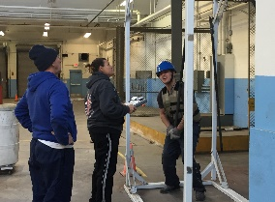
Testing and IAFF/IAFC CPAT: The Alliance and The National Testing Network (NTN), a test vendor from the State of Washington, hosted five entry level firefighter tests in 2017. The tests included candidates from Montgomery County and the eight contiguous counties. Along with entry level Fire Team tests, the Alliance can provide testing for Call-Taker/Dispatcher, Promotion, Law Enforcement, and Corrective Officers. The testing process includes human relations, mechanical aptitude, reading, and math. Once completed, the tests are scanned and emailed to NTN for scoring. Candidates may sign up for the tests and submit payment at www.nationaltestingnetwork.com. The Alliance does not set the hiring practices for members.

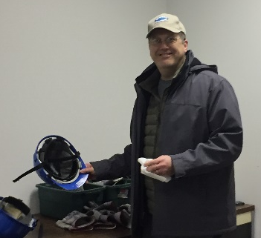
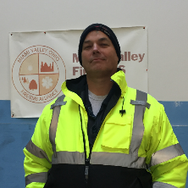
The Alliance, the City of Kettering, and the City of Dayton reached an agreement for the Candidate Physical Ability Test (CPAT) facility and equipment at the end of 2011. The CPAT test is approved by and developed by the IAFF and IAFC. The first Alliance CPAT exam was completed February 11, 2012. As a testing center for CPAT, the Alliance is authorized to conduct exams for numerous departments and individuals. The Alliance encourages all candidates to familiarize themselves through Orientation of the course and to practice to obtain the best possible result. The Alliance website, www.mvfea.com, provides information regarding the cost, conditions for testing, and a CPAT video. Additional videos may be obtained through www.YouTube.com. In 2017, the Alliance hosted six individual fire departments CPAT tests along with candidates from Ohio, New Hampshire, Connecticut, Pennsylvania, Indiana, Michigan, Kentucky, and West Virginia. Robert Hogeland, CPAT Administrator since the Spring of 2016, has provided a remarkable job in organizing and taking care of all CPAT needs. Rob is planning to hold a CPAT Proctor Training in the Spring of 2018 to allow more people to become involved with this important hiring tool.

COMMITTEE REPORTS.

Communications Committee: In 2017, the MVFEA Communications Committee was very active. Throughout the year, the committee met eight times. Michael Stewart, Dayton Fire Department stepped down as Chair and nominated David Andes, Dayton Fire Department. A vote was taken, and all were in favor of Andes as the new chair. The Communications Committee is comprised of the fire service, law enforcement, Montgomery County Communications, Montgomery County Office of Emergency Management (MCOEM), and Wright-Patterson Air-Force Base.

Several items of interest are:

- The Montgomery County Office of Emergency Management noted the reserve cache is programmed. The radios will not be turned onto MARC’s in case of a major emergency, activation can be done be the State of Ohio.
- Four SOP’s were written for Standards, Protocols, and Procedures for the Fire Departments in Montgomery County, Ohio. They are: Helicopter Radio Communications, 800MHz Nationwide Interoperability Channels, 700 MHZ Nationwide Interoperability Channels, and Talkgroup sharing. These SOP’s were presented to the Montgomery County Fire Chief’s Association.
- Special presentation by Timothy A. Shaw, JD, of Globalflyte. Shaw, retired from the FBI in Dayton, Ohio displayed how the incident command system can be brought into a vehicle from the Cloud.
- Motorola recommends tuning once a year – not 18-24 months.
- The Radio Migration is completed.

The MVFEA Communications Committee is dedicated to regional cooperation through joint effort by the many departments and organizations. The Committee has been able to save tax payers money and secure better communication by sharing knowledge and expertise.

Training Committee: The Training Committee was scheduled to meet on the second Tuesday of each month. However, the committee took a brief hiatus during the summer but id meet a total of five times during the year. The Training Committee provides excellent training opportunities for members of the fire services. Several topics are:

- Surveys
- Fire and Fire Inspection Webinars
- CPAT
- Assessment Centers
- ISO Training
- Mayday Trailer

Additional ideas for the Training Committee are: Becoming a Blue Card Training Site; Mini Training Days with local and/or mid-range speakers; Leadership Institute; CPAT Bootcamp; Back to Basics Day; and programs not offered elsewhere. Another idea is to provide at least once a year an Expo with high caliber speakers. Costs to members could be offset with sponsors.

Webinars: Members who watch the webinars are encouraged to e-mail the Alliance Office to receive a copy of a certificate for one-hour CEU’s – Fire or Fire Inspector. Non-members must pay a yearly (January through December) fee of $150 per department.

The following are the webinars presented in 2017:

- Building Construction * Phil Sinewe * January 11, 2017
- Firefighter Cancer and Senate Bill 27 * Jim Burneka * January 18, 2017
- Unmanned Aerial Systems * Sinclair UAS * February 8, 2017
- Health and Wellness * Kelly Anderson * February 15, 2017
- Code Challenge * Celina Fire Department * March 8, 2017
- Fire Behavior – A Peek Inside B Term Level 1 Class * Robert Chambers * March 15, 2017
- What Role Does the Fire Inspector Play In The 16 Life Safety Inspector Initiatives * April 12, 2017
- What Happens to Our Body When the Tones Drop? * Nurse Lori Wenning * April 19, 2017
- How the Inspector Can Assist With Preplans Related to Weather Events and General Summer Inspections * May 10, 2017
- Midwest Electric Cooperative * May 17, 2017
- Inspections and Plan Reviews * Duane Stitzel * June 14, 2017
- Basic Water Safety – Part I and Part II * June 21, 2017
- Dust and Grain Hazards for the Fire Inspector * July 12, 2017
- Cancer Legislation Update * July 19, 2017
- Backdraft / Flashover Training * Hali Abner * August 16, 2017
- Rule Changes for the Inspector * Laura Walker * October 11, 2017
- Rule Changes for the Ohio Firefighter Certification * Laura Walker * October 18, 2017
- Fire Inspections and Code Enforcement – 7th Edition – Chapter 7 – Means of Egress, Part One * November 16, 2017
- Scene Size-ups * November 16, 2017
- Fire Flow Review Preplan Reality Check for the Inspector * December 13, 2017
- Street Smart Firefighting * December 20, 2017

ALLIANCE SPONSORING AGENCY AFFILIATIONS.

The Miami Valley Fire / EMS Alliance serves as the sponsoring agency for three entities. Under the sponsorship are: The Dayton Regional Hazardous Materials Response Team, The Region 3 Rescue Strike Team, and The Ohio Task Force 1. The Alliance, as the sponsoring agency, employs all full-time and part-time employees and is responsible for financial management which includes funds from local, State of Ohio, and/or Federal Cooperative Agreement funds. The Alliance maintains all financial documents, creates financial statements and reports, performs budget management, makes payments of Federal, State, and local taxes, maintains all records required by law, and facilitates the annual Single A-133 Audit.

The Alliance is also affiliated with the Miami Valley Firefighters EMS Memorial Association by helping to promote and encourage the memorial.

Dayton Regional Hazardous Materials Response Team: The mission of the Dayton Regional Hazardous Materials Response Team (Hazmat) is to aid in bringing all incidents to a safe conclusion with the smallest negative impact on the environment and property. The team, under the guidance of Coordinator Dennis Bristow, assists Fire Departments located in Greene and Montgomery Counties. The Dayton Fire Department provides the core group of the Hazmat Team, along with members from both Greene and Montgomery Counties, and a select group of agents from private business. The Hazmat Team also has contracts with Tipp City and Monroe Township for services. Because of the commitment of the people who make up the Hazmat Team, this Team functions with a high level of expertise.
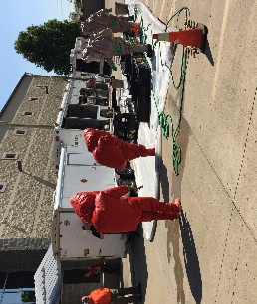
The Coordinator’s office is located with the Miami Valley Fire / EMS Alliance at 444 West Third Street, Building 20, Suite 20-231, Dayton, Ohio 45402-1460. Bristow’s coordinator position also includes being the Community Emergency Coordinator for the local Emergency Planning Committee (MGLERC).

The Hazmat Team reports to the Fire Chief of the jurisdiction where the emergency exists. At the scene, the Team Coordinator should be contacted first for a consultation, and if he/she is not available, the Duty Officer at Dayton Fire Department, Station 11 should be contacted.

Highlights for 2017 are:

- Cost Recovery efforts are current.
- Detection and Monitoring Instruments Calibration and equipment are current.
- The State-wide Hazmat Technical Advisory Committee meets or has conference calls monthly.
- The $63,520 for a new Rigaku Agent detector for unknown liquids and solids has been approved. Also requested is a grounding and bonding kit and dome clamps which totals $71,483.00 approved by the state for FY16 SHSP.
- DRONE Project is underway with six members from each platoon to be certified.
- Smith’s Detection replaced the Haz Mat 360 with the Haz Mat Elite.
- The Greene / Montgomery County SERC Exercise was on May 16, 2017 at 0800 hours. This was a Functional Exercise and was located at the Dayton Fire Department Training Center. The SERC Exercise was accepted by SERC with no exceptions.
- The Ohio Hazmat TAC adopted to require additional certification for Typed Hazmat Teams. To maintain the Type I status, Bristow conducted the Ohio Fire Academy’s Hazmat Officer and Hazmat Safety Officer classes in January and February 2017. Forty-eight team members completed the training.
- Development of a written SOG for requesting assistance from Wright-Patterson Air Force Base Fire Department for Hazmat response.
- The Team Typing three-year verification took place in December 7, 2017 with no discrepancies found.
- HMEP funding request for team training scheduled for September 2018 has been submitted.
- The mandated 2018 SERC Exercise will be conducted on May 15, 2018 at Sugarcreek Packaging in Dayton.
- The PUCO Hazardous Materials Training Grant is being reworked and all grant requests have been put on hold until July 2018.

The Hazmat Team not only responds to incidents, but also educates and trains individuals, businesses, law enforcement, and fire personnel from many municipalities to be better prepared If a hazmat incident occurs. Contact Denny Bristow, Hazmat Coordinator, at (937) 501-5112, if you would like a presentation for your department or staff.

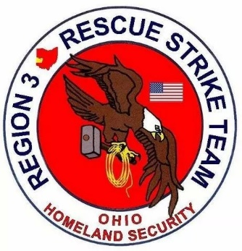
Region 3 Rescue Strike Team: The Region 3 Rescue Strike Team (R3RST) is a group of volunteers serving Ohio’s Region 3. R3RST provides equipment, resources, training, and personnel for specialized rescue incidents within the eight-county contiguous area. The counties are: Champaign, Clark, Darke, Greene, Miami, Montgomery, Preble, and Shelby. The specialized disciplines are: confined space, high-angle rescue, surface swift water, lost person search, and structural and trench collapse.

The R3RST Advisory Board meets once a year on the third Thursday in January. The Advisory Board is comprised of two representatives from each of the eight contiguous counties in Ohio’s Region 3, the Alliance Director, and the Team Coordinator. The Executive Committee is scheduled to meet on the third Thursday in April and July. Motions were made to retain Colin Altman as Chair and Lisa D’Allessandris as Vice-Chair.
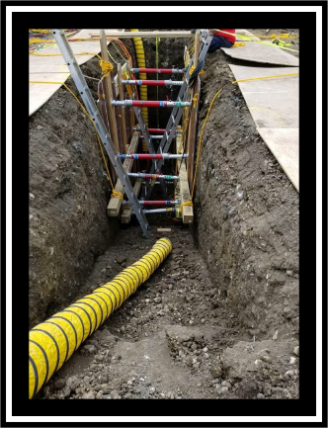
Highlights for 2017 are:

- Eight new members added.
  - Champagne (1-Christiansburg)
  - Clark (1-Pleasant Township)
  - Greene (2-Miami Township, 1-Sugarcreek Township)
  - Montgomery (2-Washington Township)
  - Shelby (1-Sidney)
- A total 60 members

- Equipment
  - Technical Rescue Response Strike Rig
  - Collapse Rescue Unit
  - Englewood Collapse and Trench POD
  - Water Rescue Response Unit

- Additional Resources
  - Beavercreek Township Rescue
  - Beavercreek Communications Vehicle
  - Dayton Fire Department Rescue Apparatus
  - Kettering Fire Department Tech Rescue Team
  - Wright-Patterson Air Force Base Technical Rescue Team
    - All Hazard Team with associated equipment
    - Dive Team
  - Lowe’s agreement for lumber
- Finance – No major expenditures in 2017.
- 2018 Budget submitted.
- VFIS insurance policy renewed.
- Team receives no state funding to operate, with no future funding projected.
- Annual expenses supported by two county chief’s organizations and two EMA’s.
- Approximately 40% of the current funding received goes to insurance and administrative expenses.
- Remaining funds go towards:
  - Quarterly trainings
  - Maintenance and upkeep of current equipment
- There is little to no funds available for new or replacement equipment purchases.
- 2017 Team Response
  - Two full team call-outs
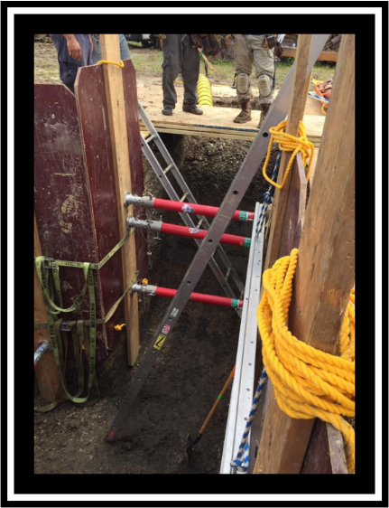
    - LPS-Pike Township, Clarke County
    - LPS-Beavercreek, Greene County
    - LPS-Union, Montgomery County
- Various phone consultations
  - LPS
  - Canine

- Team Activities
  - January Team Training
    - Equipment and Operations review
  - May Team Training
    - Shoring/Breaching/ConSpace
  - August Team Training
    - Lost person search
  - Grant Funded Training Classes completed in 2017
    - Structural Collapse Operations (SCO)
    - Trench – Level I and II
    - Rope – Level I
  - Thank you to Montgomery County EMA and Dave Neiderman for spearheading and administering the grant
- Quarterly Team Trainings for 2018 (Tentative)
  - March 29 and 30
  - May 24 and 25
  - August 30 and 31
  - October 25 and 26
- Unmanned Aerial Systems Training Exercise – May 1, 2018
- Confined Space through Cleveland State – TBD

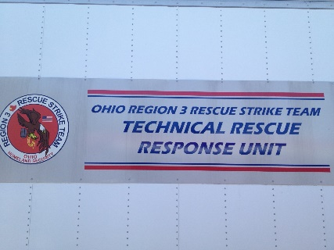

OH-TF1 Section of MVFEA 2017 Annual Report
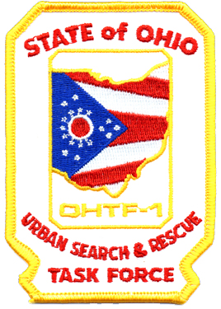

Ohio Task Force 1 Urban Search and Rescue Team
Ohio Task Force One (OH-TF1) is a State of Ohio Urban Search and Rescue (US&R) Task Force and is also one of 28 task forces that comprise the FEMA US&R System. The Alliance is the sponsoring agency for OH-TF1. The Task Force is managed day-to-day by a staff of four full-time and 17 part-time personnel. Full-time staffing consists of Program and Grants Managers, Personnel Officer, and Administrative Assistant. Part-time staffing consists of 16 logistics personnel maintaining the Task Force’s extensive cache, fleet, and facilities, and a manager of the Task Force’s canine team. All part-time positions range from a few hours per week to half-time.

TASK FORCE FUNDING
State of Ohio and FEMA funding for 2017 was approximately $1.23M; $1.18M from FEMA and $50,000 from the State of Ohio. This funding was slightly less than 2016 funding; decreases of approximately $53k and $5k in FEMA and State of Ohio funding, respectively. Expenditures for OH-TF1 in 2017 were $2,533,638:
- Federal Non-Deployment Spending
  - Administration $743,255
  - Training $173,315
  - Equipment $131,151
  - Storage/Maintenance $156,221
- State of Ohio Non-Deployment Spending
  - All Categories $43,111
- Deployment Expenditures
  - Hurricane Matthew $197,248
  - Hurricane Harvey $938,748
  - Hurricane Irma $66,042
  - Hurricane Maria $77,959
  - Hurricane Nate $3,345
  - March 2017 Severe Weather Alert $2,471
- Donation
  - Team Member Support $772

CAPITAL PROJECTS
Calendar year 2017 was the fourth year of a four-year period of extensive capital improvements. In 2014 the Task Force spent approximately $300,000 on expanding the communications cache to include 1-VSAT, 2-BGAN, and 4-MSAT satellite devices and the associated hardware and software to link all these devices to existing laptop computers and printers in a Wi-Fi environment.
In 2015 the capital improvement effort transitioned to a fleet modernization effort. At the start of 2015, the predominance of OH-TF1’s fleet consisted of prime movers (tractor trailers) and smaller tactical vehicles (pick-ups, vans, SUVs) all dating before 2005 and most before 2000.
In 2016 the updating of the Task Force’s fleet and disposal of older vehicles was well underway. OH-TF1 purchased a 2016 Sprinter Van for the canine vehicle and disposed of most of the balance of the older ones. Additional fleet upgrades were delayed due to FEMA’s delay in publishing a standardized task force fleet configuration for all 28 task forces. The new directive did not come out until December 2016.
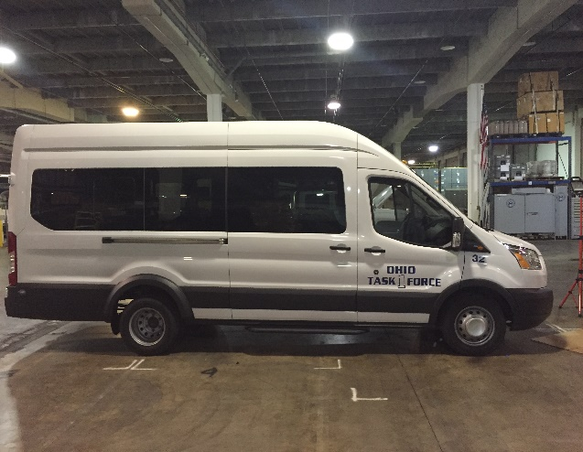
In 2017 the updating of the Task Force’s fleet and disposal of older vehicles was generally finished. OH-TF1 disposed of the 1977 Motor Coach and purchased a 2017 Sprinter Van leaving just one van or pickup to be purchased to be compliant with the December 2016 fleet movement program directive. Purchase of the final vehicle is targeted for 2018 or 2019 depending on Congressional funding amounts for the FEMA US&R System. In addition to the van, replacement of the drop deck trailer will complete the fleet upgrade. By the end of the year, OH-TF1’s deployment fleet consisted of:
- MCI 1994 Passenger Coach
- 3 – 2004 Freightliner 24 ft. Box Trucks
- 2004 Volvo Tractor
- 2008 Volvo Tractor
- 2009 Volvo Tractor
- 4 – 2014 Kubota RTVs
- 4 – 2015 Chevrolet Silverado 3500 pick-ups
- 2 – 2015 Chevrolet Tahoes
- 1 – 2016 Ford Sprinter Van
- 1 – 2017 Ford Sprinter Van

Plus, associated trailers, boats, motors, forklifts, and smaller support vehicles.
It should be noted that all replaced vehicles were sold resulting in approximately $180,000 in total sales over the three-year period. Proceeds were applied towards the purchase of the new vehicles per federal guidelines on vehicle replacement using federal funds.
Also depending on funding in 2018 and 2019, the Task Force will upgrade the Task Force’s website and a sound attenuation curtain in the training/briefing area of the warehouse will be installed.
NEW FEMA US&R MISSION – SWIFTWATER RESCUE
In 2017 FEMA implemented a new mission for the 28 task forces. In 2012 FEMA approved and assigned the mission of surface water rescue (NFPA 1670 Chapter 11) to the US&R System. Task forces, including OH-TF1, expanded their caches and fleet to include four Jon-Boats, two trailers, five motors, and a compliment of PPE for a 14-person water rescue team. Additionally, a surface water rescue specialist position description was created with an associated task book and task forces were given until January 2016 to complete training and certify their teams. OH-TF1 complied with this time line.
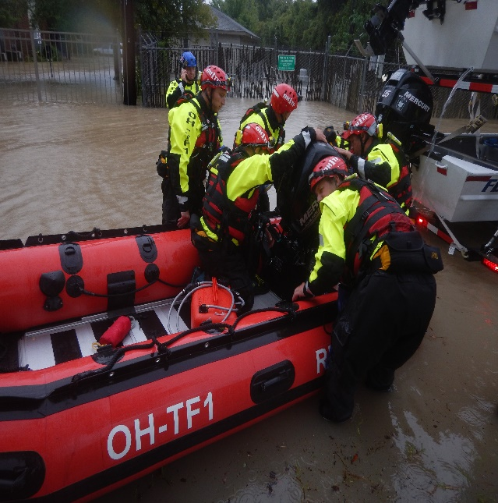
Following deployments of System task forces to flooding events in Colorado in 2013 and Hurricane Matthew in North Carolina in 2016, FEMA modified the water mission of the US&R System to Swiftwater rescue (NFPA 1670 Chapter 12). Task forces, including OH-TF1, modified their caches and fleet to include two Zodiac boats, three 30-hp motors, and the associated upgrade in PPE to work in Swiftwater, in addition to the surface water mission items. FEMA also published a Swiftwater rescue specialist position description with associated training task book and told task forces the deadline to certify to the Swiftwater mission was January 2019. OH-TF1 undertook an aggressive purchasing and training program and was able to certify to FEMA that the Task Force was mission capable as of June 2017. For OH-TF1’s deployment to Hurricane Harvey and the flooding in Houston, Texas, the Task Force was able to deploy four Jon-boats, two Zodiacs, eight motors, and the associated PPE to work in a Swiftwater environment and imbed 14 FEMA certified Swiftwater rescue specialists in the deployed task force.
TASK FORCE PERSONNEL
OH-TF1 continues to have a broad, inclusive representation of team members with 230 rostered and 203 deployable team members coming from 71 participating agencies and 50 independent team members. The Task Force also saw 11 team members resign and 12 new team members join the Task Force. Additionally, the Task Force supported seven team members to be on FEMA’s Incident Support Teams, eight team members including two chairs and a deputy chair to be on System subgroups, and 38 team members to be US&R System instructors. It is expected that in 2018 several additional appointments to the IST and subgroups will happen.
This report for the previous four years has discussed a challenge faced by Task Force leadership, that of a decline in team member contact hours each year. This report last year discussed the results of a team member survey that aimed to determine reasons for the declining participation and strategies to reverse the trend. I am happy to report that in 2017 we were able to generate a turn-around in the trend. During the year, the Task Force engaged in 125-days (34% of the calendar year) of Team contact time, a decrease from 135-days in 2016, but overall team member contact hours in 2017 were 12,290 hours, an increase of 478 hours from the 11,812 hours in 2016. The associated personnel costs of OH-TF1’s activities were approximately $711,600. Almost all of this figure uncompensated by FEMA and born on the backs of Participating Agencies or team members.
While some of the turn-around is unquestionably due to two back-to-back years of deployments (Hurricanes Matthew and Harvey in 2016 and 2017, respectively) after a three-year hiatus from deployments (2013-2015), some of the credit is due the Task Force. While the Task Force could not do much about the ability of team members to get away from work or family commitments – the two most cited causes of conflict for Team engagement – the Task Force did significantly improve the quantity and quality of the communication with the team members (developed a team wide email group) and the Task Force supported an expansion of training opportunities that included new events and more support for travel to these events; the third and fourth suggestions for improvement to Team participation.
TASK FORCE ACTIVITIES 2017
Training and Exercises:
The Task Force has a lot to be proud of for its accomplishments in 2017. Examples include the annual Go-Green training (200 team members completed), a group of 16 team members represented OH-TF1 at the Rescue Challenge in Virginia, team members continued to support State of Ohio and Ohio National Guard exercises by supporting exercise planning efforts, use of the Task Force’s training facility, and filling ICS C&GS positions for Ohio’s Health and Human Services Mega-Death and ONG exercises. Additionally, we hosted a FEMA US&R System canine evaluation and the US&R System’s, four-day, Heavy Equipment and Rigging (HERS) course. We also hosted a three-day class of documentation training for transportation of hazardous materials and the All Hazards Logistics Section Chief Course. These evaluations, trainings, and exercises included broad representation from both Ohio first responders as well as guardsmen, coroners, elected officials, EMA personnel, and personnel from other FEMA task forces. The support provided by OH-TF1 fulfills a key primary justification for the Task Force existing; to pass on our experience to others so they can apply that knowledge to department and local emergencies. Finally, Task Force personnel completed 209 monthly or bi-monthly team trainings and attended 29 national and regional FEMA meetings, trainings, and evaluations.
Deployments:
Calendar year 2017 also saw the deployment of a Type III, 48-person, Task Force to Hurricane Harvey. The storm dumped more than 27 trillion gallons of rain over Texas, making Harvey the wettest Atlantic hurricane ever measured. Many parts of Houston received more than 50 inches of rainfall with one reporting location indicating more than 60 inches – so much that the National Weather Service had to update the colors it uses on its weather charts to properly account for it. With one-third of Houston completely flooded, the weight of the water also sank the city temporarily by two centimeters (almost an inch), according to a California geophysicist.
On Friday, August 25, 2017, President Trump signed a Disaster Declaration authorizing federal support for the Harvey response and recovery efforts. This triggered the response of multiple federal assets to include elements from all 28 of the FEMA Urban Search and Rescue (US&R) Task Forces, the Blue Incident Support Team (IST), two Haz-Mat Equipment Push Packages (HEPP), and other supporting resources. OH-TF1 was part of the initial six task forces assigned to the Houston area being activated by FEMA on Thursday, August 24, 2017, at 10:30 p.m.
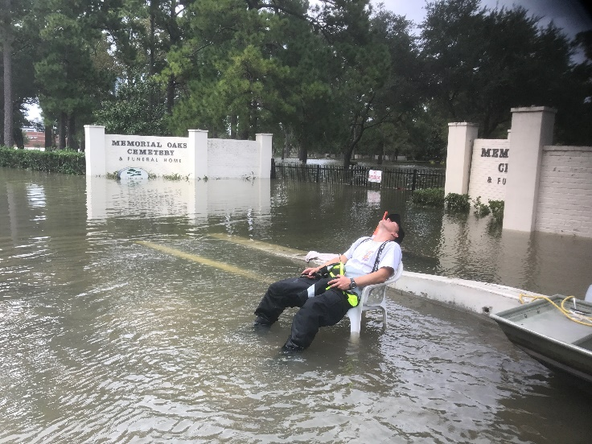
Into this disaster OH-TF1 arrived in the morning hours of August 26, 2017, and over the 12-day deployment the Task Force would travel 3,027 road miles, 46.3 boat miles, complete 173 human rescues or assists, 40 animal rescues or assists, and conducted primary searches over a 52.3 square mile area.
Additionally, while the Task Force would not deploy another team the rest of the hurricane season, OH-TF1 also supported the Nation’s responses to Hurricanes Irma, Maria, and Nate throughout the rest of September and into October deploying five personnel each to IST positions for Hurricanes Irma and Maria, and one person to Hurricane Nate.
TASK FORCE ACTIVITIES 2018
Having achieved a turnaround in team member participation, we have created a lot of energy with our efforts and deployments the past several years and keeping that energy with activities already planned for 2018 is going to be our focus. First up in January, the Task Force is sending five team members to the ICS S-420 class for IST credentialing. On March 2 and 3 the Task Force will complete our yearly Go-Green training requirements. Over April and May the Task Force will be conducting the Swiftwater training days necessary to comply with US&R System and NFPA Swiftwater mission requirements. In May we are also sending a 20-person Rescue Team back to Virginia to compete in the Rescue Challenge. September will be this year’s only Task Force Orientation Day and the three-day class on documentation training for transportation of hazardous materials. While OH-TF1 was not identified to host a canine evaluation this year, and the next hosting of the HERS class is not until 2019, the Team will be busy with an aggressive schedule of individual and joint team trainings. Over two weeks in September and the first week of October the Task Force will complete the Structural Collapse Specialist course and a 24-hour continuous rescue training covering all five disciplines of the NFPA 1006 Rescue Standard.
FEMA also has an aggressive schedule in 2018 of meetings and trainings that almost always involve one or more OH-TF1 team members. Also, the hurricanes forced the postponement of the multi-task force exercise OH-TF1 was leading the planning. The exercise has been rescheduled for June 2019. There will be the need to continue the planning meetings in 2018. Finally, the Task Force will remain receptive to requests from entities within and outside of Ohio to support training and exercise needs and for training opportunities that team members become aware and express interest.
For the paid staff, beyond supporting Team and team member’s needs, our focus will include some capital improvement projects, a huge undertaking to clean up nearly 20 years of record retention issues, and the generation of a number of new written procedures and policies to get ready for our tri-yearly visit by the FEMA US&R System’s Administrative Readiness Evaluation (ARE) team.
As always, on behalf of Sponsoring Agency Chief, Jeffrey Payne, and myself, thank you to the Alliance for their continued support of the Task Force.

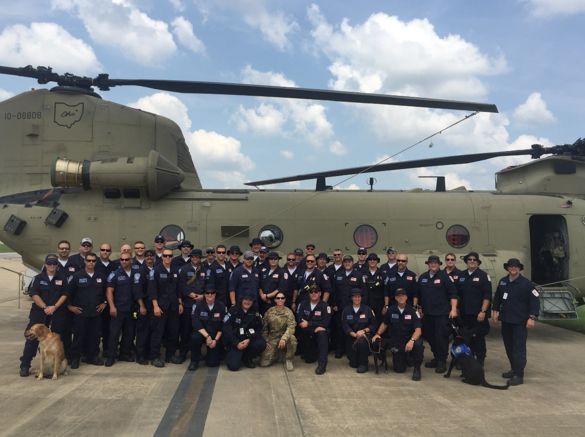
REFLECTION FROM THE EXECUTIVE DIRECTOR.

It was 1991 when Chief Thomas Grile, of Huber Heights, suggested there might be a better way to deliver fire and emergency services to our communities. He believed there could be more efficient and effective alternatives to the current delivery systems we were using. The fire service was changing and the way we were doing business just might be becoming obsolete. In response to this call of action, John Auberzinski, Ray Hughes, Randy Staley, Charles Wiltrout, James Nichols, Paul Hemmeter, Paul Hutsonpillar, and a host of others launched the Miami Valley Fire/EMS Alliance in May 1995. The Alliance tackled many complex and challenging tasks; including establishing the first region wide firefighter skill checkoff sheets which, as most of you remember, were the forerunner of the NFPA 1001 checkoffs used not only by the Sinclair Fire Academy but, the state as well. The county numbering systems came from the Alliance. Yes, at one time everyone had a different name or number assigned to a piece of apparatus. Ladders were called many things; trucks, ladders, units, and aerials to mention a few. Engine were engines, pumpers, trucks or units depending on who was dispatching. Medics were ambulances, rescues, medics, transports, and some other names that were just to odd to explain in the little space we have here. When Miami Valley Emergency Management Agency dissolved and obviously was not able to house the Haz Mat Team anymore, the Alliance stepped forward to fill the void. Without the Alliance there would probably not be a USAR team in the area. The list of accomplishments and services provided to the fire and emergency services in our region by the Alliance is extensive. The road wasn’t easy, but as the adage goes, nothing worthwhile is.
But that was the past. As we look into 2018 and beyond, the issues and challenges might seem overwhelming. But the same spirit and vision that was the driver of the advancement for the fire service in the beginning continues to this day as the tool of development for the quality of services we provide the customers. Do we define the change or react to it? With the Alliance we will continue to be the driver of the change. This is the Alliance Advantage.
